**DAY 19**

**File Search:**

**Write a command to find all files with the extension .txt in the /home directory and its subdirectories.**

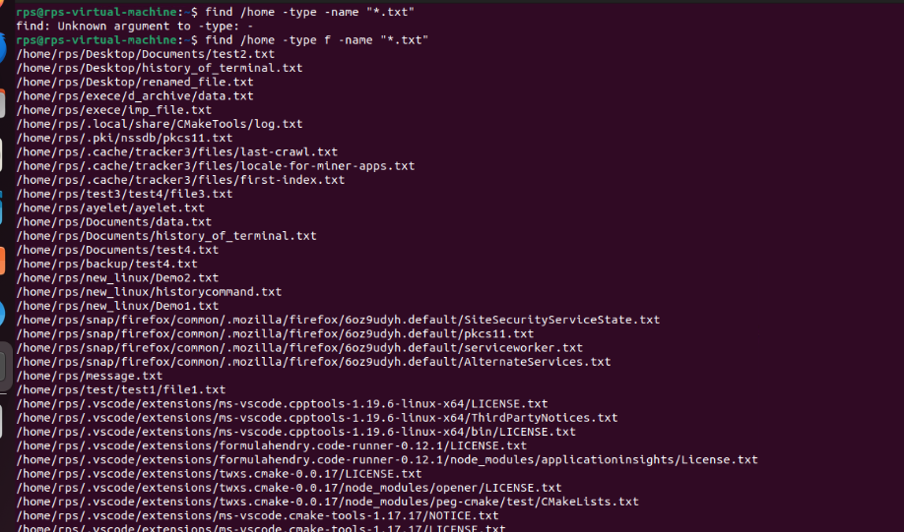

**File Permissions:**

**Write a command to change the permissions of all files in the /var/log directory to 644.**

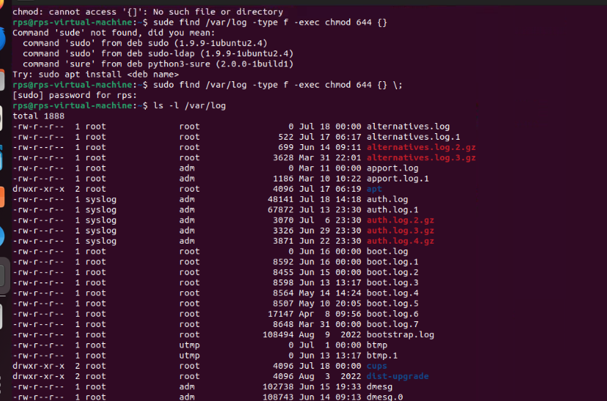

**Disk Usage:**

**Write a command to display the disk usage of all directories in the /home directory in a human-readable format.**

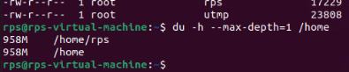

**Process Management:**

**Write a command to list all running processes that contain the name "apache" in their command line.**

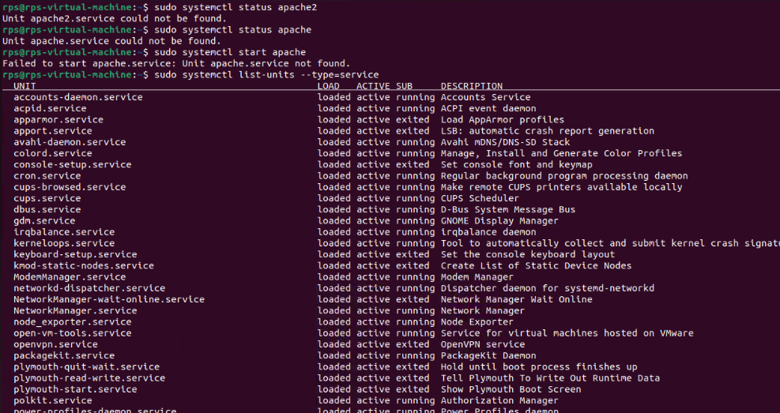

**Text Processing:**

**Write a command to count the number of lines in a file named error.log.**

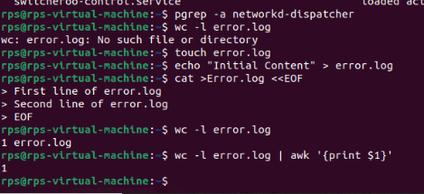

**Network Configuration:**

**Write a command to display the IP address of all network interfaces on the system.**

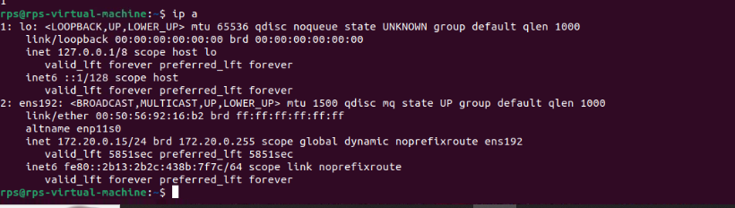

**Package Management:**

**Write a command to install a package named htop using the package manager.**

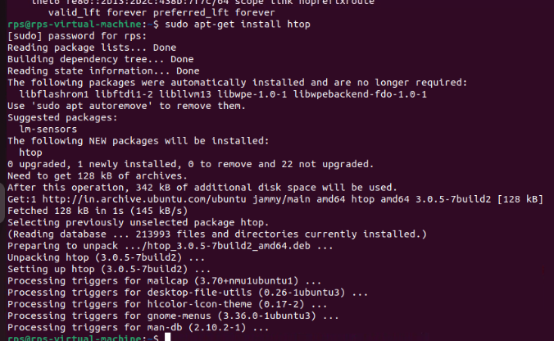

**User Management:**

**Write a command to add a new user named developer to the system.**

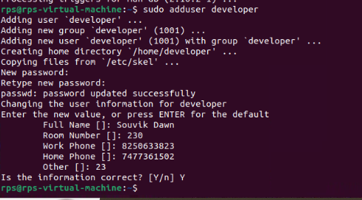

**File Compression:**

**Write a command to compress a directory named backup into a .tar.gz file.**

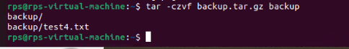

**System Monitoring:**

**Write a command to display real-time system resource usage, including CPU, memory, and disk I/O.**

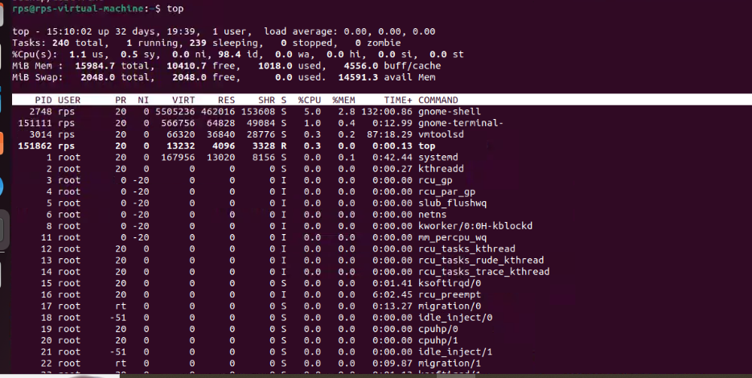

**Shell Scripts**

**Backup Script:**

**Write a shell script to back up a directory named /data to /backup with the current date appended to the backup file name.**

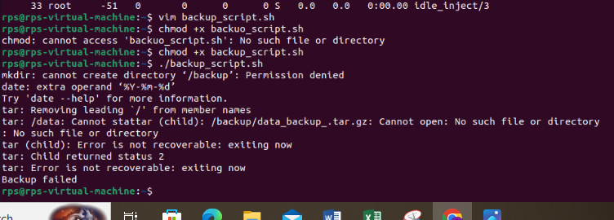

**Log Rotation:**

**Write a shell script to rotate log files in the /var/log directory, keeping only the last 7 days of logs.**

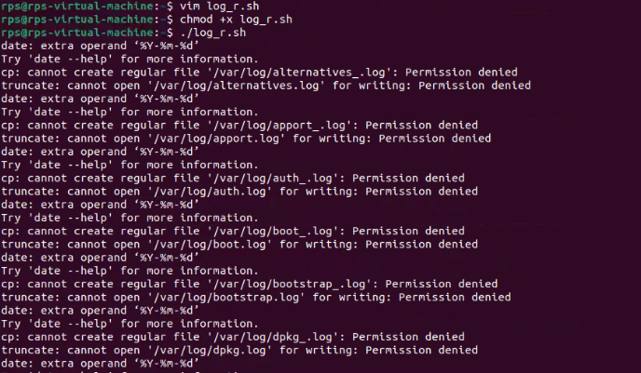

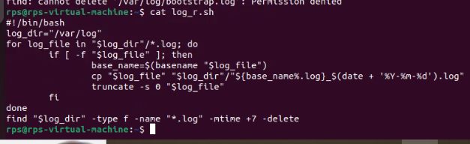

**Disk Space Alert:**

**Write a shell script to check the disk usage of the /home directory and send an email alert if the usage exceeds 80%.**

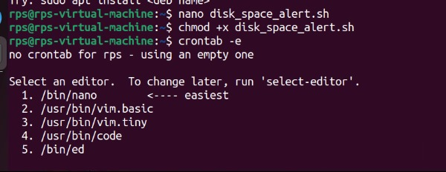

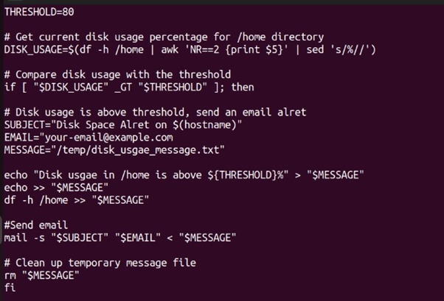

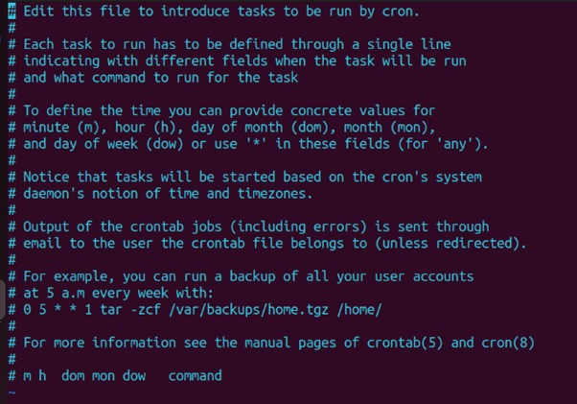

**User Report:**

**Write a shell script to generate a report of all users currently logged into the system and save it to a file named user_report.txt.**

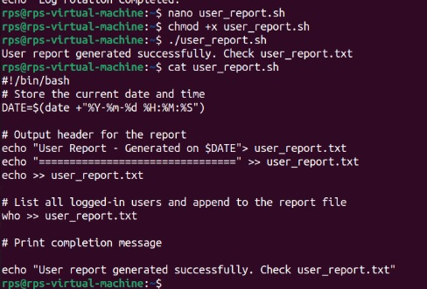

**Service Monitor:**

**Write a shell script to check if the nginx service is running and restart it if it is not.**

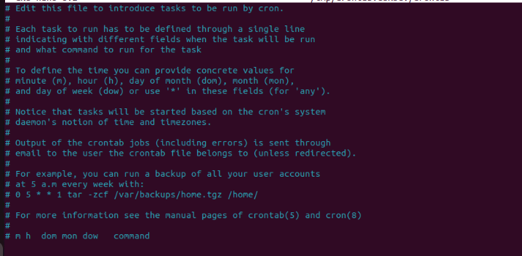

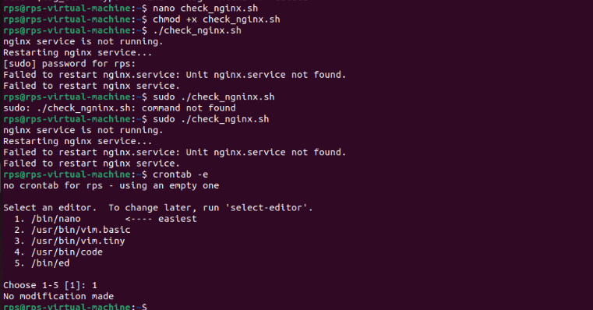

**File Cleanup:**

**Write a shell script to delete all files older than 30 days in the /tmp directory.**

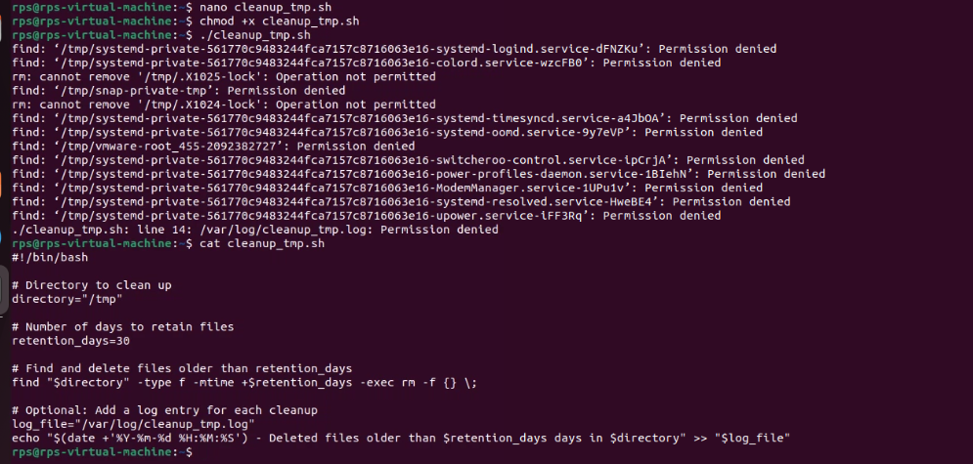

**Automated Updates:**

**Write a shell script to automatically update all installed packages on the system**.

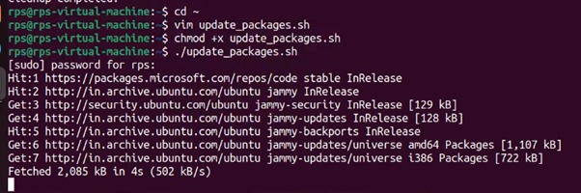

**Database Backup:**

**Write a shell script to back up a MySQL database named sales to a file named sales_backup.sql.**

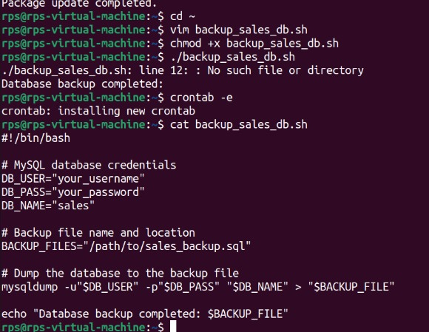

**System Information:**

**Write a shell script to display system information, including hostname, OS version, and kernel version.**

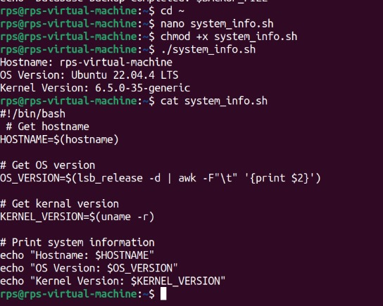

**Cron Job:**

**Write a shell script to schedule a cron job that runs a specific command every day at midnight.**

